**05 - Formal Order of Accuracy 1D Advective Test**

1D advection case should get almost 'exact' orders of accuracy both in space and time. If the 1D test works, it means that the basic spatial/temporal operators are fine and we can focus on other components.

For the 1D test, only rho is evolved, with an initial shape rho(x,t=0) (gaussian function a·exp(-0.5 x^2)) and periodic boundary conditions. Analytically, the function rho(x,t=0) is transported unchanged, and after one (or multiple) turn-over times, L/a (where L is the length of the domain and a is the constant velocity) it is again in the initial position. Hence, the error after a few (i.e 5) turn-over time.

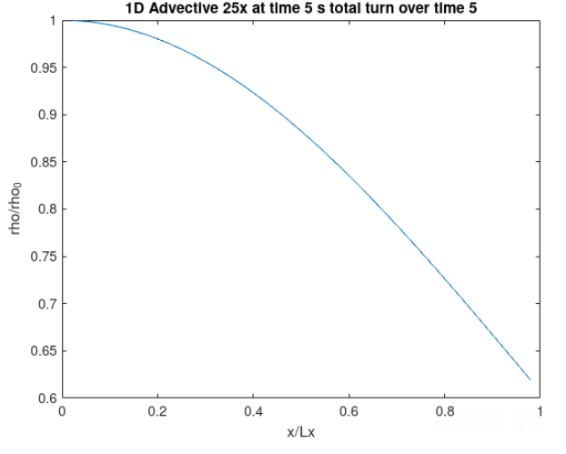

However, in order to have it symmetrical, a sinusoidal shape is used (sin(2piX)).

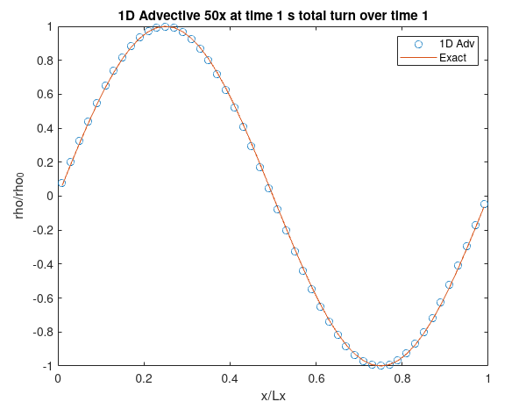

1. **Spatial Evolution**

Fixed time step of 1e-2 with Ngrid 50,100 and 200 yielding CFL of 0.5, 1 and 2 respectively.

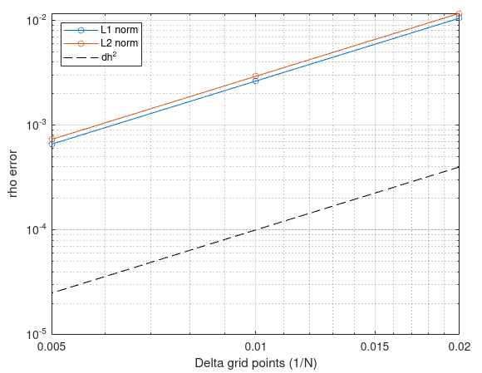

1. **Time Error**

Regarding time, it is really important to use a solution obtained with a small time step as exact. Your numerical solution is something like

y_num = y_exact + O(h^2) + O(Dt^4) => E = y_num - y_exact = O(h^2) + O(Dt^4)

When doing the spatial study, it is fine to use the analytical solution because the spatial error is dominant, and what you see in practice is a O(h^2) term. In the temporal case, instead, you would end up with a mixed term.

1. Exact solution > Analytical

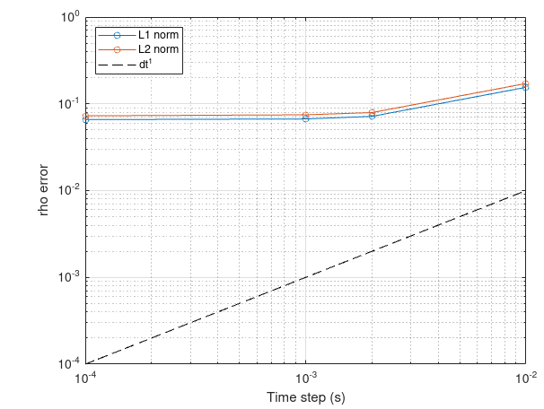

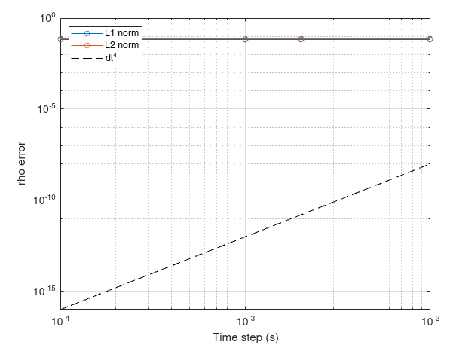

1. Exact solution > Numeric with low time step lowest from 1e-3, 1e-2,2e-2,1e-1 with N grid 20.

